Power BI Visuals Assignment

Question 1: Create a Card Visual to show Total Sales.
ANSWER
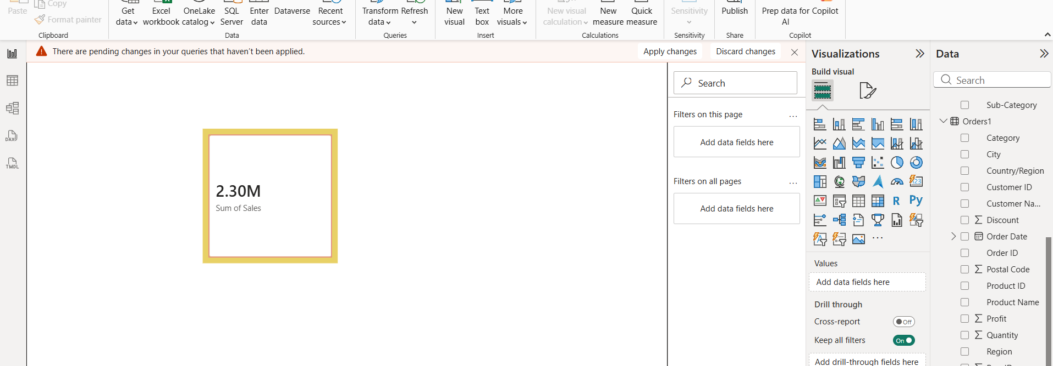

Question 2: Create a Donut Chart showing Total Sales by Ship Mode and which ship mode generates the highest sales?
ANSWER
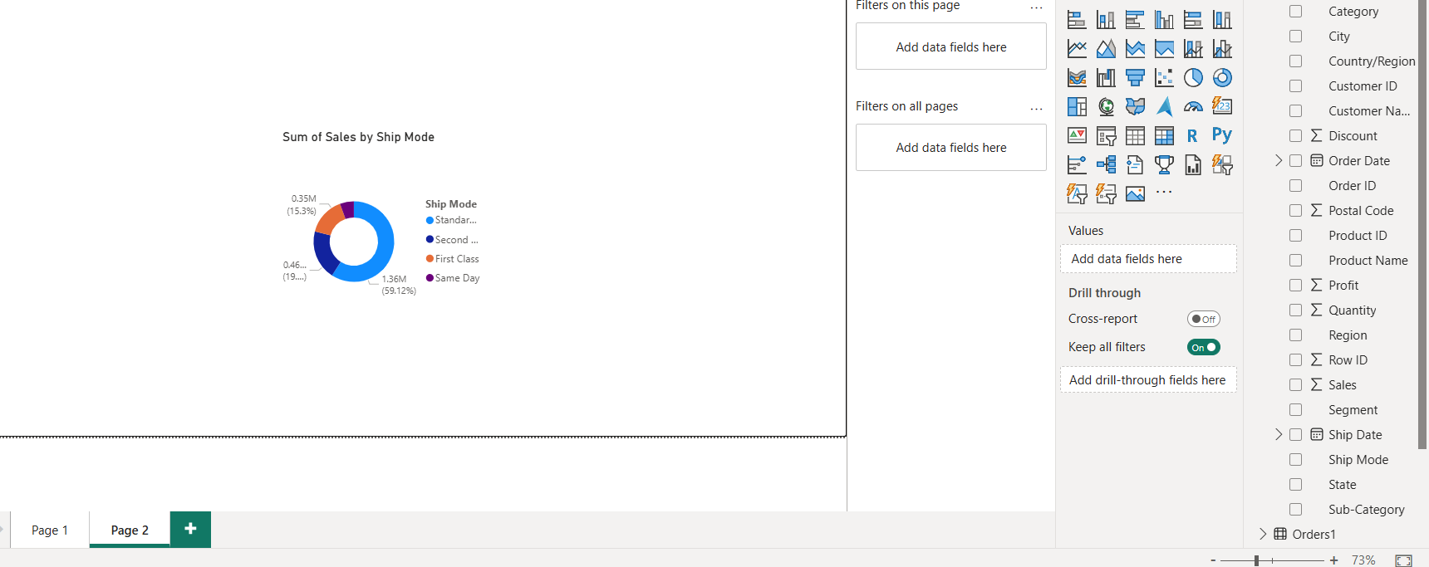

In the ship mode standard class made highest sale

Question 3: Create a Line Chart showing the Sales Trend over time (by Month and Year). Is there any noticeable seasonal pattern in sales?

ANSWER

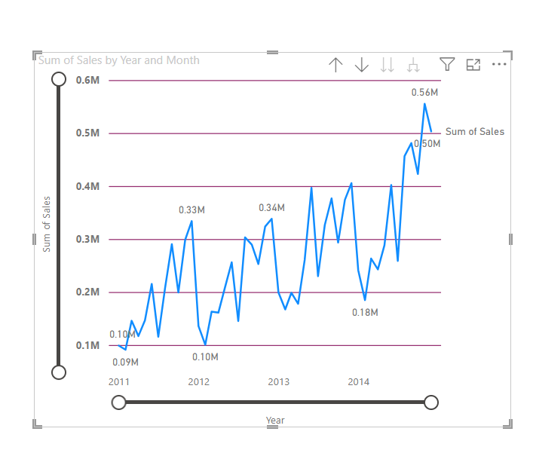
Sales are growing steadily year over year 2014 highest sale

Question 4: Create a Bar Chart to compare Sales by Category.
ANSWER
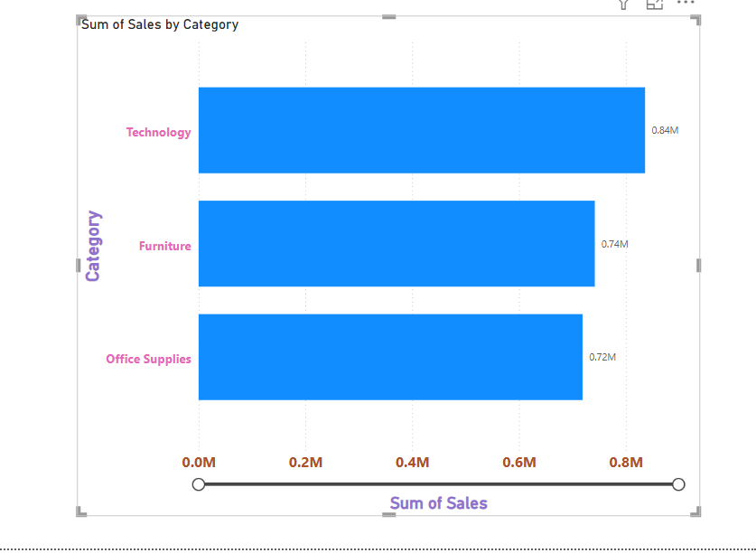

Question 5: Create a Matrix Visual to display Sales by Month and Category and identify the month with the highest sales.
ANSWER

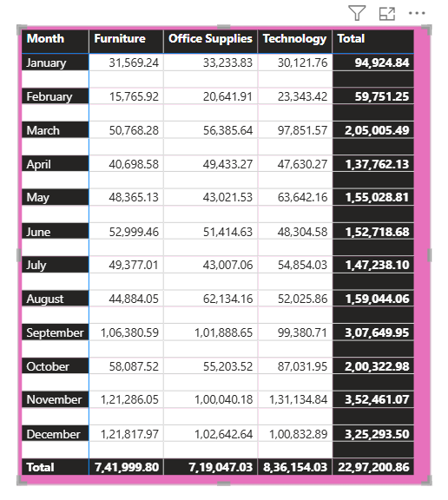
Question 6: Create a Decomposition Tree for Sales Breakdown.

ANSWER

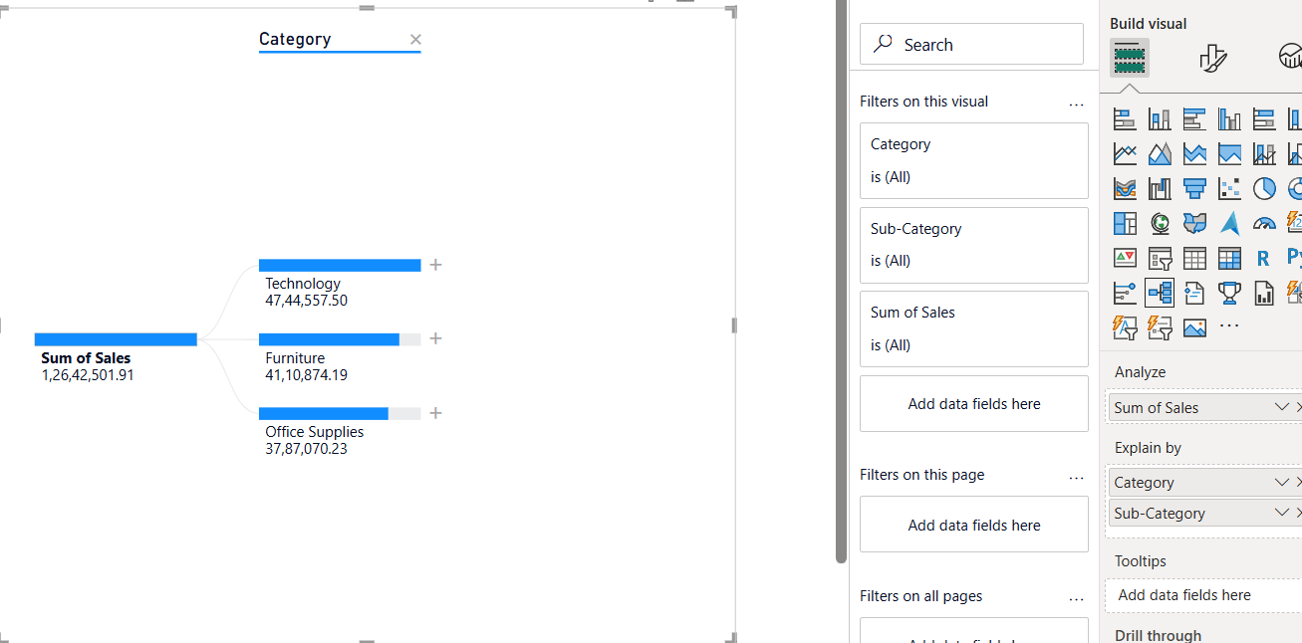
Sub-category shows plus icon .

Question 7: Create a Scatter Chart to compare Discount vs. Profit by Sub-Category. Are there any outliers where high discounts resulted in negative profit?
ANSWER 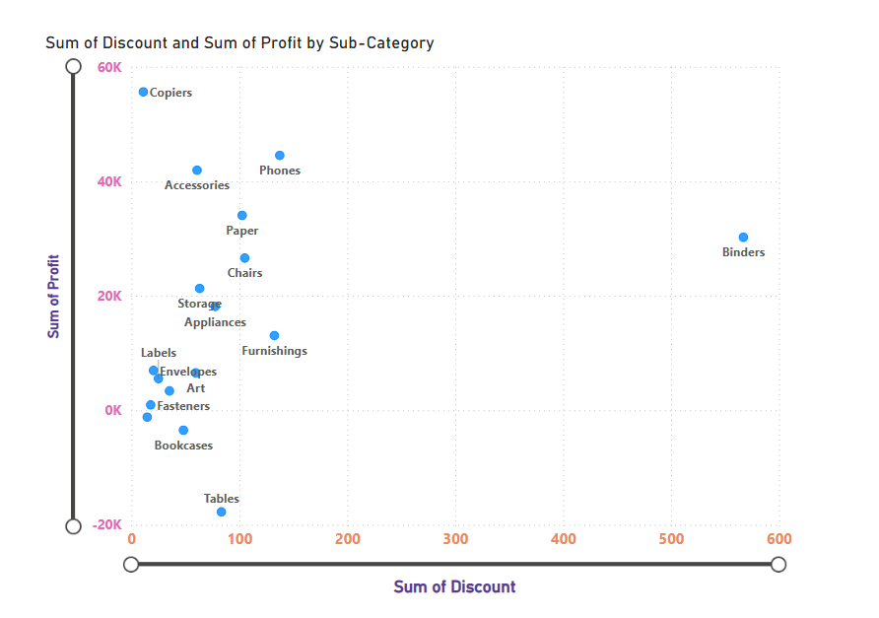
Look for outliers. Often, high discounts in Furniture (Tables/Bookcases) lead to negative profit.

Question 8: Use a Funnel Chart to show the number of orders by Customer Segment.
ANSWER
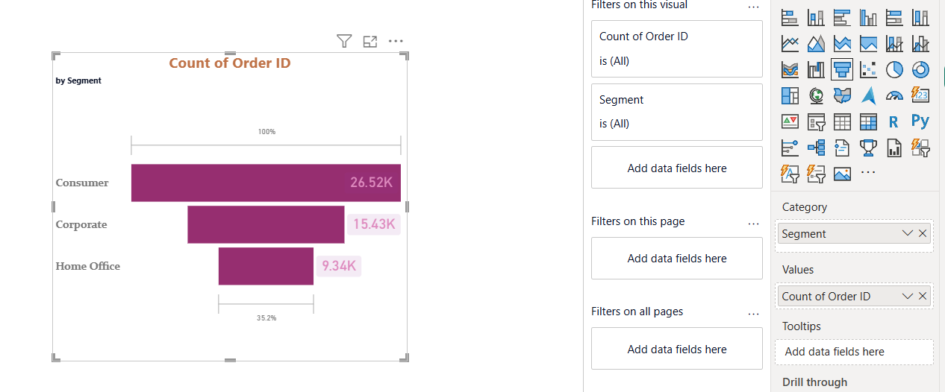

Question 9: Use a Waterfall Chart to analyze how Profit changes by Category within the countries.
ANSWER
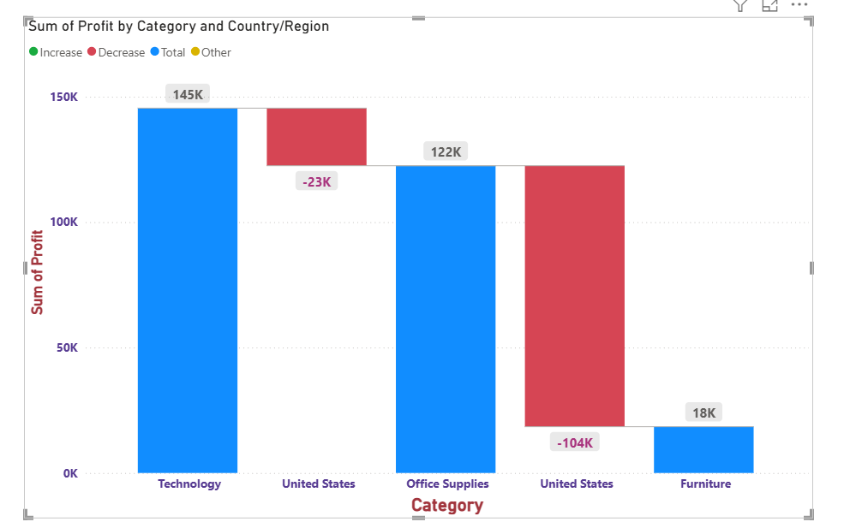

Question 10: Create a Dual-Axis Line Chart to show Total Sales and Profit Over Time (by Month).

ANSWER

